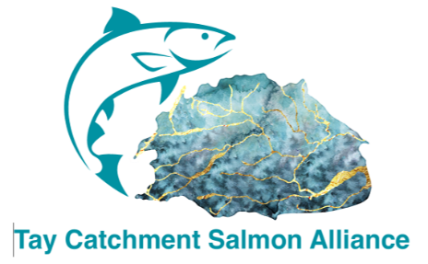

The TCSA invites you to a symposium:

Conservation Stocking:
A Necessary Intervention for a Species on the Brink
Scotland’s Atlantic salmon are declining faster than policy and science are adapting. While some continue to dismiss stocking outright, new evidence shows that targeted, genetically responsible stocking can support recovery when natural recruitment has collapsed. This symposium challenges outdated narratives and presents the case for action before extinction becomes a policy choice rather than an ecological inevitability.
Why This Matters
Scotland’s wild salmon are now at historically low abundance, with many rivers experiencing recruitment failures that natural processes alone cannot reverse. Habitat restoration remains essential, but it is not keeping pace with the rate of decline. Without intervention, several catchments risk losing their salmon entirely within a generation.
This symposium brings together leading practitioners, geneticists, hatchery managers, and river specialists to examine evidence-based stocking as a tool for recovery — not a replacement for habitat work, but a necessary support where populations are collapsing. The event aims to move the debate beyond ideology and towards practical, scientifically defensible action.

Event Details
- Date: 11 November 2026
- Venue: Birnam Arts Auditorium, Station Rd, Dunkeld PH8 0DS
- Time: 08:30 Registration & Coffee
- Cost:
  - In person: £40 (Includes symposium entry, tea/coffee throughout the day, and soup & sandwich lunch)
  - Via TEAMS: £30
This symposium is expected to be extremely popular — please book early to avoid disappointment.

Who Should Attend
This event is designed for anyone involved in the future of Scotland’s rivers and wild salmon, including:
- District Salmon Fishery Boards
- Fisheries Trusts and river restoration organisations
- Hatchery managers and stocking practitioners
- Marine Scotland, SEPA, NatureScot and policy officials
- Angling clubs and associations
- Conservation NGOs
- Academics and students in ecology, genetics, and fisheries science
- Estate managers, landowners, and river proprietors
- Anyone concerned about the future of Atlantic salmon in Scotland
The symposium is deliberately practical, evidence-led, and focused on solutions, not stalemates.

Programme
AGENDA ITEM | TIME INC QUESTIONS | AGENDA ITEM | SPEAKER
1 | 0830 | Coffee, Registration & Badging
2 | 0900 | Welcome
3 | 0910 | Keynote address | Dr John Taylor
4 | 1010 | Coffee
5 | 1020 | River Carron Project | Bob Kindness MBE
6 | 1125 | River Cree Hatchery | Murdo Crosbie
7 | 1225 | Buffet Lunch
8 | 1315 | Saving Norwegian Rivers | Norwegian Environment Agency
9 | 1415 | Coffee
10 | 1430 | Lies, Damn Lies & Statistics | David Bamford
11 | 1500 | *Panel Discussion and Open Forum | Facilitators
12 | 1600 | Salmon Genetics | Maureen Hess, California
13 | 1635 | Final statements
14 | 1700 | Close

Key Outcomes
By the end of the symposium, attendees will:
- Understand the current scientific evidence for conservation stocking
- Learn how stocking can be carried out responsibly and genetically safely
- See real-world examples from Scotland, England, and international programmes
- Gain clarity on when stocking is appropriate — and when it is not
- Explore how stocking fits alongside habitat restoration and catchment management
- Hear from geneticists on risk mitigation and best practice
- Participate in an open forum shaping practical recommendations for Scotland
- Leave with a clearer sense of what action is needed now to prevent further loss
This event is designed to move the conversation forward and provide Scotland’s river managers with the tools, evidence, and confidence to act.

Booking Information
Attendees will be able to register via our online booking form. The link for the form is below or use the QR Code. When you have filled in the form and submitted you will receive an email with Payment instructions. Payment will be by one of the following:
- Pay-by-Bank (ATOA)
- BACS transfer
- Cheque by post
Booking form link:
Tay Catchment Salmon Alliance Symposium Booking – Fill in form


Thank you for your interest and we look forward to seeing you on
11 November 2026!!

